CMPE312 – OPERATING SYSTEMS TERM PROJECT REPORT

SUBJECT: THE SANTA CLAUS

ELİF NAZ ERÇİN – 117200058

**INTRODUCTION: THE SANTA CLAUS PROBLEM DEFINITION**

The Santa Claus problem is a classic synchronization issue in computer science. It is named after the anecdotal character Santa Claus, who is known for conveying gifts on Christmas Eve. The problem includes coordinating the activities of Santa Claus and a group of elves and reindeer to guarantee the smooth operation of gift delivery.

The issue is ordinarily defined as takes after:

* Santa Claus rests until either all of the mythical people or a few of the reindeer are prepared.
* When all the elves are prepared, they collectively wake up Santa Claus.
* Santa Claus can either offer assistance the elves or take a ride with the reindeer.
* If Santa Claus chooses to assist the elves, he performs a few work with them and after that they go back to rest.
* If Santa Claus chooses to require a ride with the reindeer, they provide the endowments and after that all the reindeer go back to rest.
* After Santa Claus wraps up making a difference the elves or riding with the reindeer, he goes back to rest until the another gather is prepared.

The objective of the Santa Claus issue is to plan a arrangement that guarantees the taking after conditions are met:

* Santa Claus is stirred when either all the elves are prepared or a few of the reindeer are prepared.
* Only one gather (either the elves or the reindeer) can be helped/ride with Santa Claus at a time.
* Santa Claus must offer assistance all the elves some time recently he can take a ride with the reindeer.
* If Santa Claus is making a difference the elves, no reindeer ought to be permitted to begin conveying blessings.
* If Santa Claus is riding with the reindeer, no elves ought to be permitted to wake him up.

The Santa Claus issue challenges software engineers to actualize a arrangement that arranges the exercises of Santa Claus, elves, and reindeer effectively, guaranteeing that blessing conveyance is appropriately overseen.

**CODE EXPLANATION**

1. Include Header Records: The code starts by counting the essential header records stdio.h, pthread.h, and semaphore.h for input/output, pthreads, and semaphores, separately.

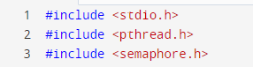

1. Define Constants: Two constants are characterized - NUM_REINDEER and NUM_ELVES - speaking to the number of reindeer and mythical beings, individually.
2. Declare Semaphores and Factors: Four semaphores and two factors are pronounced. The semaphores are:

* reindeerSem: Semaphore for reindeer to hold up until all of them have arrived.
* santaSem: Semaphore for Santa Claus to hold up until signaled by reindeer or mythical beings.
* elfTex: Semaphore for elite get to to the numElves variable (utilized by mythical people).
* mutex: Mutex for securing basic areas of the code (utilized by all strings).

The factors are:

* numElves: The number of mythical people requiring offer assistance.
* reindeerCount: The number of reindeer that have arrived.

1. Implement Reindeer String Work: The reindeer work is mindful for the behavior of the reindeer strings. It starts by augmenting the reindeerCount variable and checking in the event that all reindeer have arrived. In case all reindeer have arrived (reindeerCount == NUM_REINDEER), it signals Santa Claus by posting to the reindeerSem semaphore. Something else, it discharges the mutex by posting to the mutex semaphore.

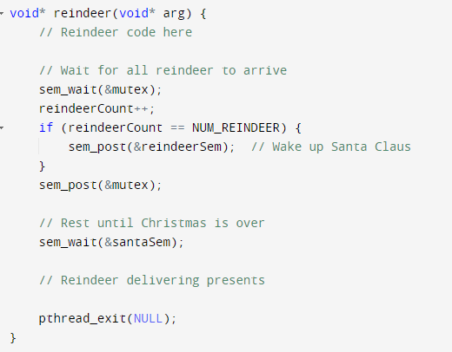

Another, the string holds up until Santa Claus signals the santaSem semaphore, demonstrating that it's time to provide presents. After conveying presents (not appeared within the code), the thread exits.

1. Implement Elf Thread Function: The elf function speaks to the behavior of the elf threads. The elves line up for offer assistance by increasing the numElves variable. In case the number of elves comes to 3 (numElves == 3), the elf signals Santa Claus by posting to the santaSem semaphore. Something else, it discharges the elfTex semaphore, permitting other elves to line up.

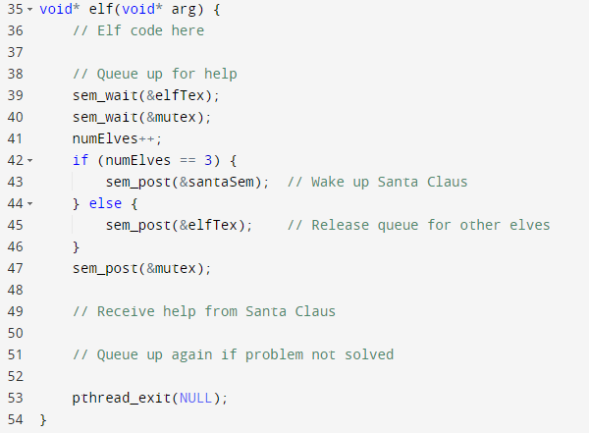

After receiving help from Santa Claus (not shown in the code), the thread exits. If the problem is not solved, the elves can queue up again.

1. Implement Santa Claus String Work: The santaClaus function speaks to the behavior of the Santa Claus string. It runs in an unbounded circle, holding up for reindeer to reach. When the reindeerSem semaphore is signaled, it implies that all reindeer have arrived, and Santa Claus plans the sleigh and conveys presents. At that point, it signals the conclusion of Christmas by posting to the santaSem semaphore.

After delivering presents, Santa Claus checks if there are at least three elves waiting for help. If so, it releases the mutex by posting to the mutex semaphore and proceeds to help the elves. Otherwise, it releases both the elfTex and mutex semaphores.

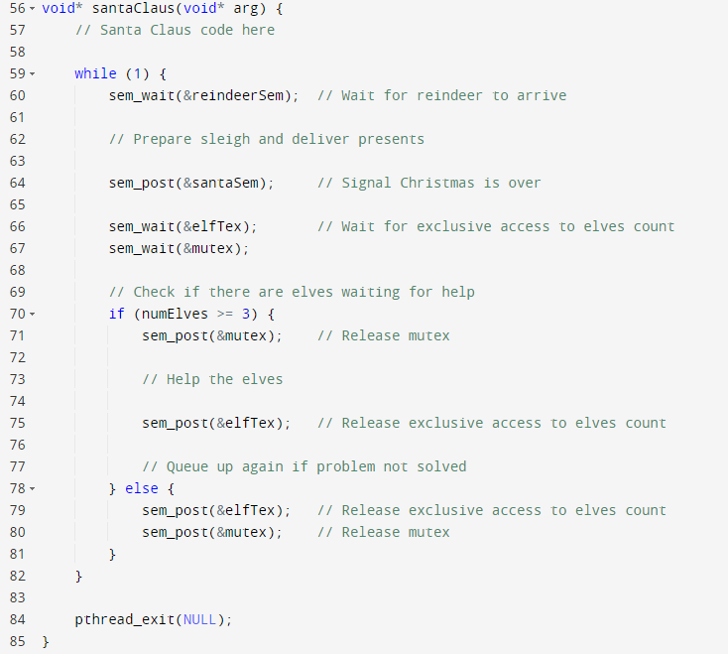

1. Implement Main Function: The main function is where the program starts. It initializes the semaphores using sem_init and creates the Santa Claus, reindeer, and elf threads using pthread_create.

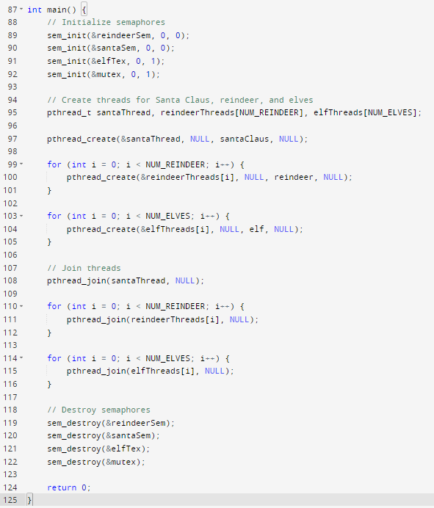

After creating the threads, the main function waits for the Santa Claus thread to finish using pthread_join, followed by the reindeer and elf.